5.123: a) See Exercise 5.38; 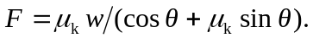
b)
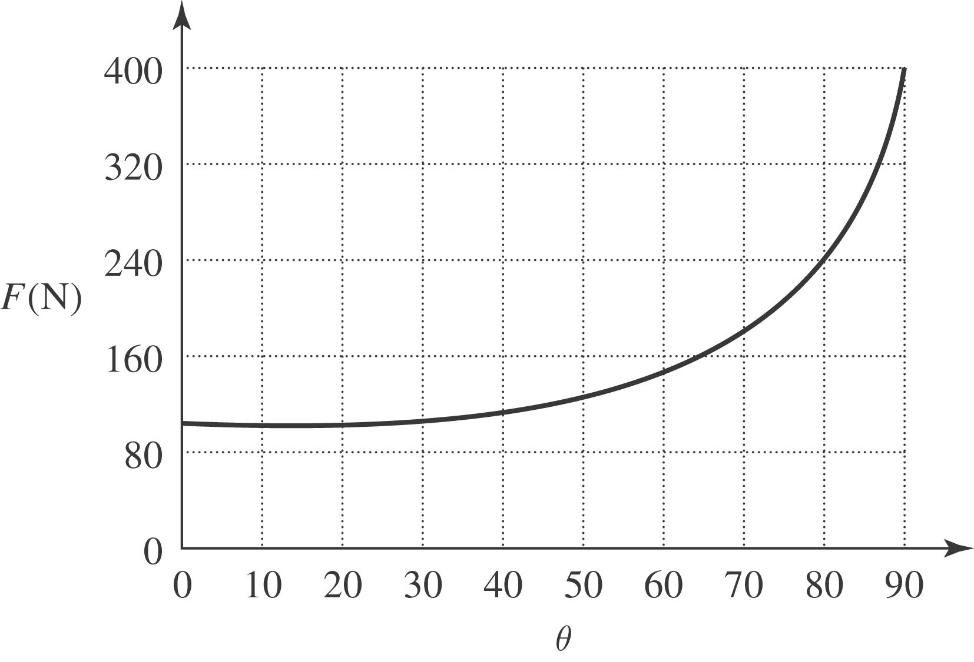

c) The expression for F is a minimum when the denominator is a maximum; the calculus is identical to that of Problem 5.77 (maximizing w for a given F gives the same result as minimizing F for a given w), and so F is minimized at 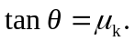 For 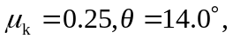 keeping an extra figure.

